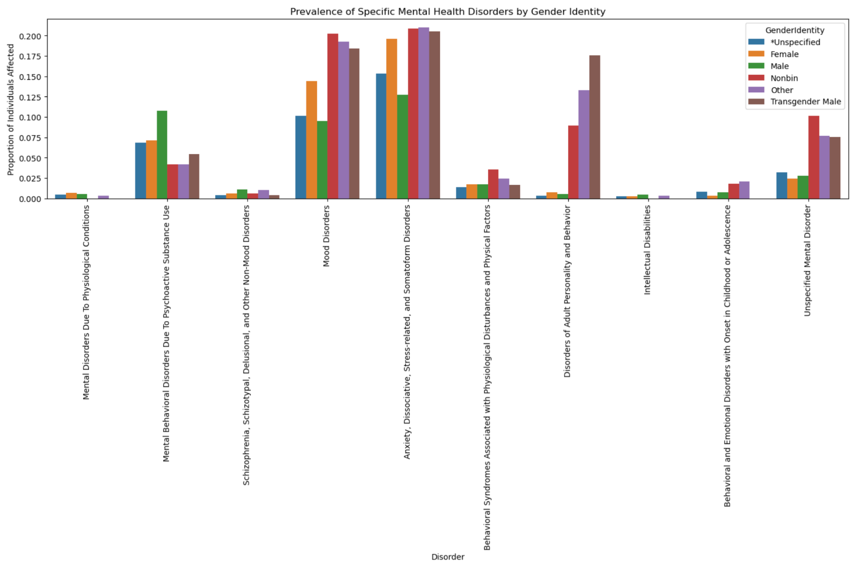

Code:
import pandas as pd
import matplotlib.pyplot as plt
import seaborn as sns

# Load the dataset
file_path = 'SOM June 2025 - Summer Project File - deidentified_Additional Data.csv'
df_som = pd.read_csv(file_path)

# Define mental health-related columns
mental_health_cols = [
'Mental Disorders Due To Physiological Conditions',
'Mental Behavioral Disorders Due To Psychoactive Substance Use',
'Schizophrenia, Schizotypal, Delusional, and Other Non-Mood Disorders',
'Mood Disorders',
'Anxiety, Dissociative, Stress-related, and Somatoform Disorders',
'Behavioral Syndromes Associated with Physiological Disturbances and Physical Factors',
'Disorders of Adult Personality and Behavior',
'Intellectual Disabilities',
'Behavioral and Emotional Disorders with Onset in Childhood or Adolescence',
'Unspecified Mental Disorder'
]

# Filter for top 6 most frequent Gender Identities
top_gender_identities = df_som['GenderIdentity'].value_counts().nlargest(6).index.tolist()

# Calculate average (proportion) of each disorder by Gender Identity
disorder_rates_by_gender = df_som[df_som['GenderIdentity'].isin(top_gender_identities)]
disorder_rates_by_gender = disorder_rates_by_gender.groupby('GenderIdentity')[mental_health_cols].mean().reset_index()

# Melt the dataframe for plotting
disorder_rates_melted = disorder_rates_by_gender.melt(
id_vars='GenderIdentity',
var_name='Disorder',
value_name='Proportion'
)

# Plot using seaborn
plt.figure(figsize=(15, 10))
sns.barplot(data=disorder_rates_melted, x='Disorder', y='Proportion', hue='GenderIdentity')
plt.title('Prevalence of Specific Mental Health Disorders by Gender Identity')
plt.xticks(rotation=90)
plt.ylabel('Proportion of Individuals Affected')
plt.tight_layout()
plt.show()

Analysis:
- Genderqueer individuals have the highest rates of several mental health disorders, especially mood disorders and anxiety-related conditions.
- People who chose not to disclose their gender identity also show consistently high prevalence across most mental health categories.
- Females (based on gender identity) tend to have higher rates of mental health issues compared to males, particularly in mood and stress-related disorders.
- Disorders like personality disorders, substance-related disorders, and behavioral syndromes are also more common in non-binary and undisclosed groups than in traditional male/female identities.
- Overall, the data suggests that non-binary, gender-diverse, and undisclosed groups experience a disproportionately higher burden of mental health issues, which may point to underlying social, cultural, or systemic stressors.
2.
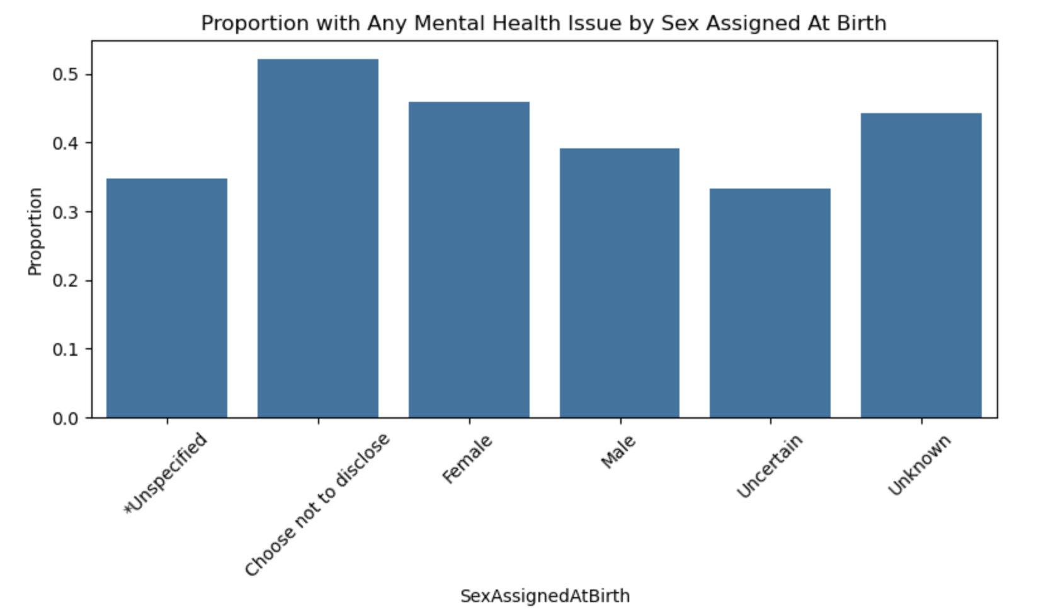
Code:
# Proportion of any mental health issue by SexAssignedAtBirth
import pandas as pd
import seaborn as sns
import matplotlib.pyplot as plt

# Load data
df = pd.read_csv('SOM June 2025 - Summer Project File - deidentified_Additional Data.csv')

# Define relevant columns
mental_health_cols = [
'Mental Disorders Due To Physiological Conditions',
'Mental Behavioral Disorders Due To Psychoactive Substance Use',
'Schizophrenia, Schizotypal, Delusional, and Other Non-Mood Disorders',
'Mood Disorders',
'Anxiety, Dissociative, Stress-related, and Somatoform Disorders',
'Behavioral Syndromes Associated with Physiological Disturbances and Physical Factors',
'Disorders of Adult Personality and Behavior',
'Intellectual Disabilities',
'Behavioral and Emotional Disorders with Onset in Childhood or Adolescence',
'Unspecified Mental Disorder'
]

# New column: Any mental health issue
df['Any_Mental_Health_Issue'] = df[mental_health_cols].sum(axis=1) > 0

# Group by SexAssignedAtBirth
sex_summary = df.groupby('SexAssignedAtBirth')['Any_Mental_Health_Issue'].mean().reset_index()

# Plot
plt.figure(figsize=(8, 5))
sns.barplot(data=sex_summary, x='SexAssignedAtBirth', y='Any_Mental_Health_Issue')
plt.title('Proportion with Any Mental Health Issue by Sex Assigned At Birth')
plt.ylabel('Proportion')
plt.xticks(rotation=45)
plt.tight_layout()
plt.show()
Analysis:
Proportion= Total number of people in that groupNumber of people with ≥1 mental health diagnosis​
- Females assigned at birth have a higher proportion of reported mental health issues than males.
- Those who chose not to disclose their sex or were marked as "Uncertain" also show high prevalence, possibly due to underlying social or identity stressors.
3.
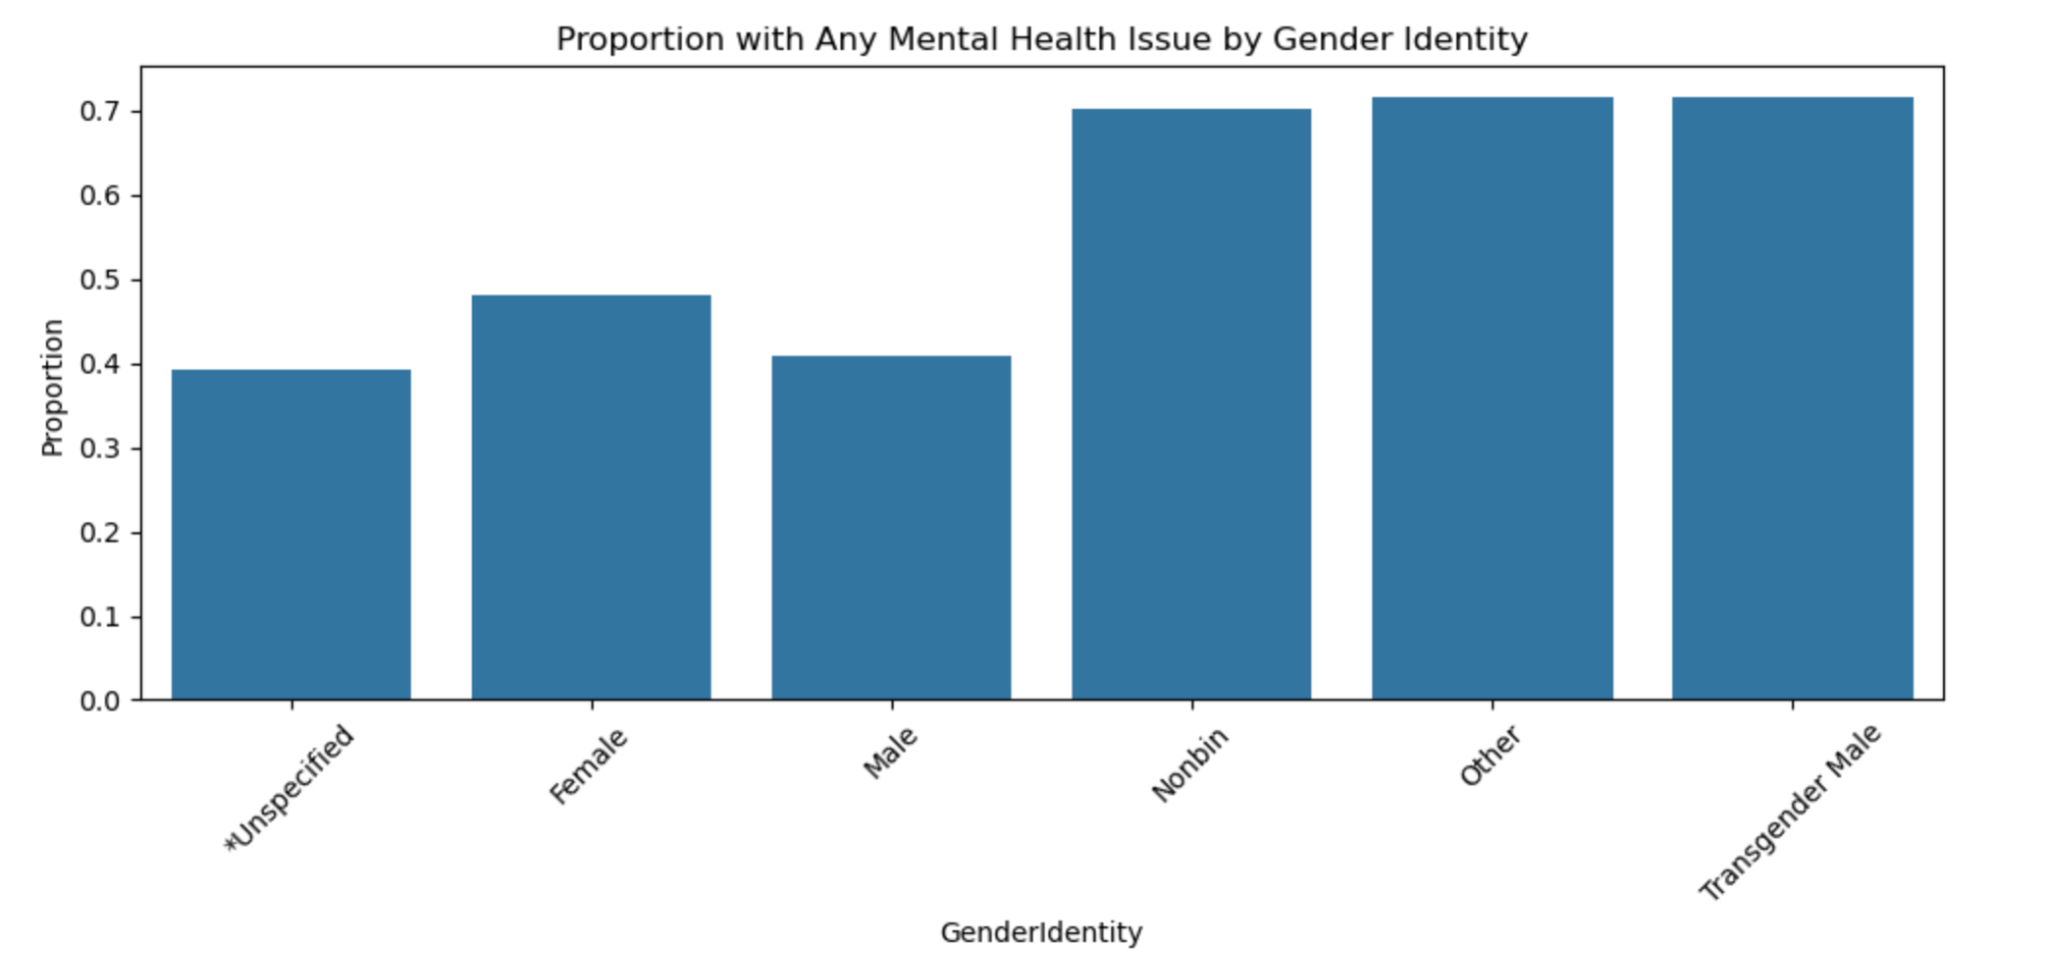

Code:
# Group by GenderIdentity
gender_summary = df.groupby('GenderIdentity')['Any_Mental_Health_Issue'].mean().reset_index()

# Focus on the top 6 most common identities
top_genders = df['GenderIdentity'].value_counts().nlargest(6).index.tolist()
gender_summary_top = gender_summary[gender_summary['GenderIdentity'].isin(top_genders)]

# Plot
plt.figure(figsize=(10, 5))
sns.barplot(data=gender_summary_top, x='GenderIdentity', y='Any_Mental_Health_Issue')
plt.title('Proportion with Any Mental Health Issue by Gender Identity')
plt.ylabel('Proportion')
plt.xticks(rotation=45)
plt.tight_layout()
plt.show()

Analysis:
Proportion= Total number of people in that groupNumber of people with ≥1 mental health diagnosis​

- Genderqueer individuals have the highest prevalence of mental health issues among all identity groups.
- People who chose not to disclose their gender identity also show significantly elevated rates.
- Females again have higher rates than males, while males report the lowest among the top six identities.
4. 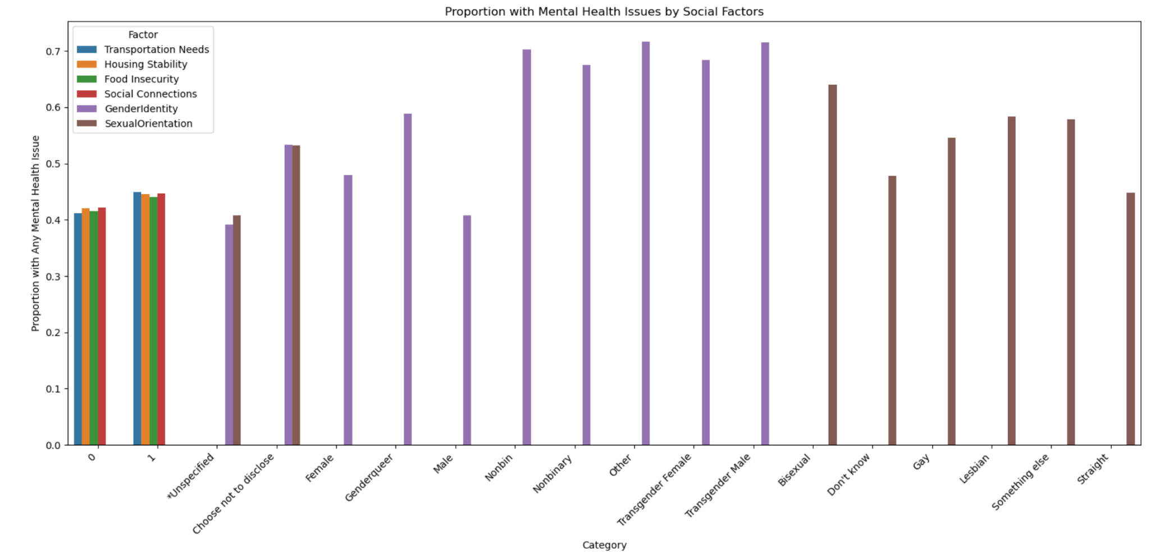
Code:
import pandas as pd
import matplotlib.pyplot as plt
import seaborn as sns

# Load your dataset
df = pd.read_csv("SOM June 2025 - Summer Project File - deidentified_Additional Data.csv")

# Define relevant mental health columns
mental_health_cols = [
'Mental Disorders Due To Physiological Conditions',
'Mental Behavioral Disorders Due To Psychoactive Substance Use',
'Schizophrenia, Schizotypal, Delusional, and Other Non-Mood Disorders',
'Mood Disorders',
'Anxiety, Dissociative, Stress-related, and Somatoform Disorders',
'Behavioral Syndromes Associated with Physiological Disturbances and Physical Factors',
'Disorders of Adult Personality and Behavior',
'Intellectual Disabilities',
'Behavioral and Emotional Disorders with Onset in Childhood or Adolescence',
'Unspecified Mental Disorder'
]

# Create binary column for having any mental health issue
df['Any_Mental_Health_Issue'] = df[mental_health_cols].sum(axis=1) > 0

# Define key social factors to analyze
social_factors = [
'Transportation Needs',
'Housing Stability',
'Food Insecurity',
'Social Connections',
'GenderIdentity',
'SexualOrientation'
]

# Create a combined dataframe for plotting
results = []
for factor in social_factors:
if df[factor].nunique() <= 20: # limit to manageable category sizes
temp = df.groupby(factor)['Any_Mental_Health_Issue'].mean().reset_index()
temp['Factor'] = factor
temp.columns = ['Category', 'Proportion', 'Factor']
results.append(temp)

plot_df = pd.concat(results)

# Plot
plt.figure(figsize=(16, 8))
sns.barplot(data=plot_df, x='Category', y='Proportion', hue='Factor')
plt.title('Proportion with Mental Health Issues by Social Factors')
plt.ylabel('Proportion with Any Mental Health Issue')
plt.xticks(rotation=45, ha='right')
plt.tight_layout()
plt.show()

Analysis:
0 = 0% of people in that group have any diagnosed mental health issue.
0.5 = 50% of people in that group have at least one diagnosed mental health issue.
1 = 100% of people in that group have a mental health issue (this would be rare).

1. Housing, Food, and Transportation Needs
- People experiencing housing instability, food insecurity, or transportation challenges have significantly higher rates of mental health issues.
- In some groups, over 50% reported a mental health condition — a clear signal that basic needs are deeply tied to mental well-being.

2. Lack of Social Connections
- Individuals reporting no or weak social connections show a notably higher mental health burden.
- This supports the idea that social isolation is a major mental health risk factor.

3. Gender Identity
- Gender-diverse groups — such as nonbinary, transgender, and "other" — consistently show higher proportions of mental health issues than binary identities (male/female).
- This points to the impact of identity-related stress, stigma, or lack of support.

4. Sexual Orientation
- People identifying as gay, lesbian, bisexual, or queer also show elevated rates compared to heterosexual individuals.
- Again, this may reflect minority stress and lack of affirming resources.

Overall Takeaway:
- The data supports what many clinicians already observe — that mental health is strongly shaped by unmet social needs and identity-based challenges.
- These insights can help justify investments in preventative care, community support, and mental health resources, even when they don’t immediately drive revenue.

